**HEALTH CARE SYSTEM**

**MIDDE MOUNESH YADAV, BANKA DILEEP, KOTA AKASH, V.HEMANTH SIVA KUMAR Prof. GARIMA SHARMA**

Student, Computer Science and Engineering, Parul University, Vadodara, Gujarat, India

Student, Computer Science and Engineering, Parul University, Vadodara, Gujarat, India

Student, Computer Science and Engineering, Parul University, Vadodara, Gujarat, India

Professor, Computer Science and Engineering, Parul University, Vadodara, Gujarat, India

**ABSTRACT**

The most crucial element of every person’s existence is their health. To maintain good health and frequent monthly checkups are needed. These days, ordinary people do not have much time to get their health checked. In this situation, technology plays a crucial role. Machine Learning techniques are used for a lot of applications. In healthcare, machine learning is crucial in predicting the diseases. It is currently the most popular and successful area of medical treatment. Accurate analysis of medical data aids early disease identification, patient treatment, and community services as a result of machine learning advancements in the biomedical and healthcare sectors. We will create a GUI to ask the user for their symptoms. We are utilizing 4(for example like KNN, DT) machine learning models in this analysis. The output includes the condition, the model’s precision, a definition of the disease, and a treatment plan based on the patient’s reported symptoms. We are all familiar with the proverb that states, ”Early detection and treatment of disease are far preferable to late-stage treatment.” To consult the appropriate doctor and maintain good health, this project identifies the illness based on the patient’s described symptoms.

**Keywords:** Machine Learning, GUI, KNN, Decision Tree

1. **INTRODUCTION**

Health is crucial for every individual. Due to busy schedules, people often neglect routine health check-ups. Early disease detection is vital, and this project aims to assist in predicting diseases based on symptoms using ML. The model considers symptoms provided by the user and predicts the most probable disease along with its description and treatment. This project helps to get an idea about an individual’s disease based on the symptoms he/she has, and get the treatment easily by contacting the concerned doctor. A disease predictor can also be called a virtual doctor, which can predict the disease based on symptoms. This disease predictor system can be most useful as it identifies the disease without even contacting the individual

1. **METHODOLOGY**

**1. Research and Analysis:**

**Research Approach** The research was conducted by reviewing existing literature on ML applications in healthcare, analyzing various disease prediction models, and comparing their effectiveness. Different ML algorithms were tested on healthcare datasets to determine their accuracy and efficiency in disease prediction.

**Key areas of focus include:**

* **Machine Learning in Healthcare** – Utilization of ML models (Decision Tree, KNN, Naive Bayes, Random Forest) for accurate disease prediction.
* **System Development** – GUI-based prediction model, chatbot integration, and SQLite database for patient history management.
* **Implementation and Testing** – Model training, performance evaluation (accuracy score, confusion matrix), and validation using cross-validation techniques.
* **Future Enhancements** – Expanding datasets, incorporating deep learning, improving chatbot functionality, and developing a web-based platform.

**2. Data Collection :**

* The dataset was collected from Kaggle and other medical repositories.
* Data preprocessing techniques such as normalization and feature selection were applied to improve model performance.
* Data consisted of 133 symptoms and 41 diseases, ensuring a broad range of predictions

**3. Model Comparison:**

* **Naive Bayes:** Best for probabilistic classification but struggles with dependent features.
* **Random Forest:** Effective for high-dimensional data but computationally expensive.
* **Decision Tree:** Easy to interpret but prone to overfitting.
* **KNN:** Good for pattern recognition but slow for large datasets.

**Evaluation Metrics**

* **Accuracy Score:** Measures the correctness of the predictions.
* **Confusion Matrix:** Evaluates true positives, false positives, and other classification aspects.
* **Cross-validation Score:** Ensures model reliability across different datasets.

**4. Requirement Gathering**

**Functional Requirements**

* The system must allow users to input symptoms and predict diseases.
* It should support multiple ML models for better accuracy.
* A chatbot should assist users in symptom identification.
* The system should store patient history for future reference.

**Non-Functional Requirements**

* The system should provide fast and accurate predictions.
* Data security and privacy must be maintained.
* The GUI should be user-friendly and intuitive.
* The system should be scalable to accommodate more diseases in the future.

**5. Design and Planning**

**System Architecture** The system consists of:

* A **front-end GUI** built using Tkinter for user interaction.
* A **processing unit** handling ML models for disease prediction.
* A **backend database** using SQLite for storing patient records.

**6. Quality Assurance and Testing**

**Quality Assurance Measures**

* Ensuring model accuracy through rigorous training and validation.
* Implementing security measures for data privacy and integrity.
* Regular code reviews and performance evaluations.
* Maintaining a user-friendly and error-free GUI.

**III. MODELING AND ANALYSIS**

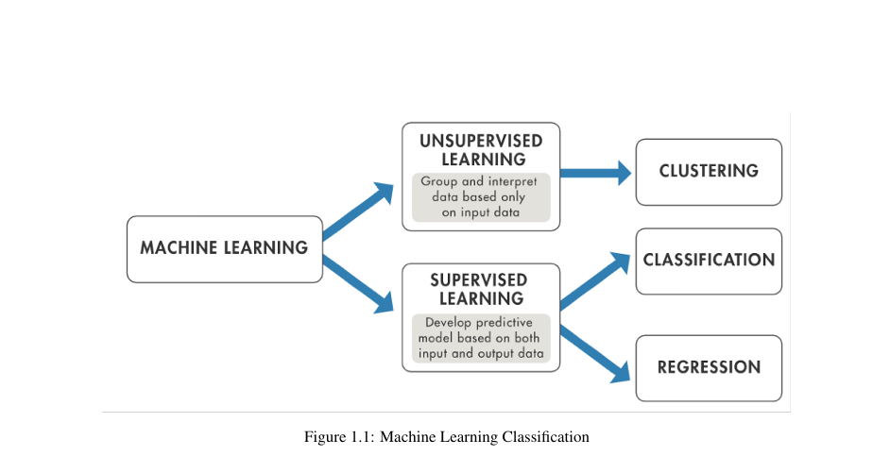

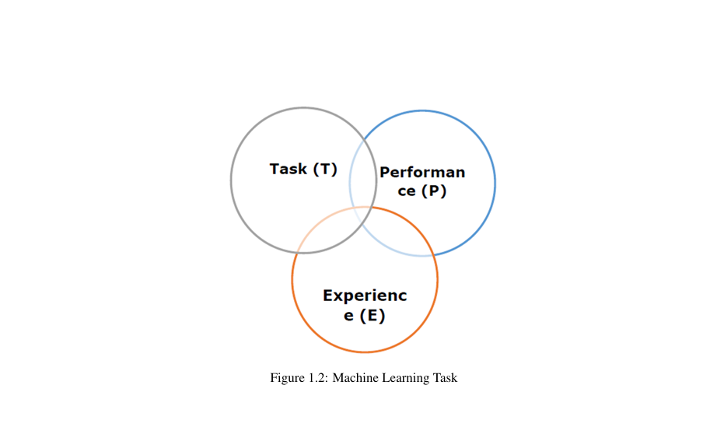

**IV. RESULTS AND DISCUSSION**

**Results and Discussion**

**Model Performance**

* The Random Forest model achieved the highest accuracy among all tested algorithms.
* Naïve Bayes provided quick predictions but struggled with complex feature dependencies.
* Decision Tree performed well but had issues with overfitting.
* KNN showed promising results but required extensive computational resources.

**Observations**

* The GUI interface successfully facilitated disease prediction with user-friendly interactions.
* Storing patient data in SQLite enabled future reference and analysis.
* The chatbot functioned effectively, guiding users in symptom identification.

**Challenges and Limitations**

* The model’s accuracy depends on the quality and size of the dataset.
* Some rare diseases were not well predicted due to limited training data.
* Further optimization is needed to reduce response time for real-time applications.

**Hardware and Software Requirements**

**Hardware Requirements:**

* Processor: Intel Core i5 or higher
* RAM: 8GB or more
* Storage: Minimum 256GB SSD
* Operating System: Windows, macOS, or Linux
* GPU (optional): Recommended for deep learning enhancements

**Software Requirements:**

* Programming Language: Python
* Libraries: Pandas, Sklearn, Matplotlib, Seaborn, Tkinter
* Database: SQLite
* Development Tools: Jupyter Notebook, PyCharm, or VS Code
* Operating System Compatibility: Windows, macOS, Linux

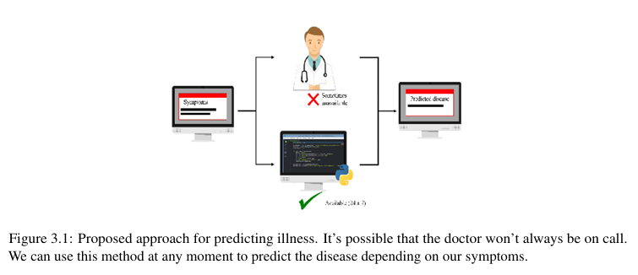

**Algorithm**

• Import libraries and Dataset.

• Data Pre-processing

• Data Visualization

• Model Building

• Model Evaluation

• Deployment of the model

1. GUI

2. Chatbot

• Based on user-provided symptoms, predict the disease.

**ADVANTAGES OF THE PROPOSED SYSTEM**

• Easily analyze the disease

• High Accuracy

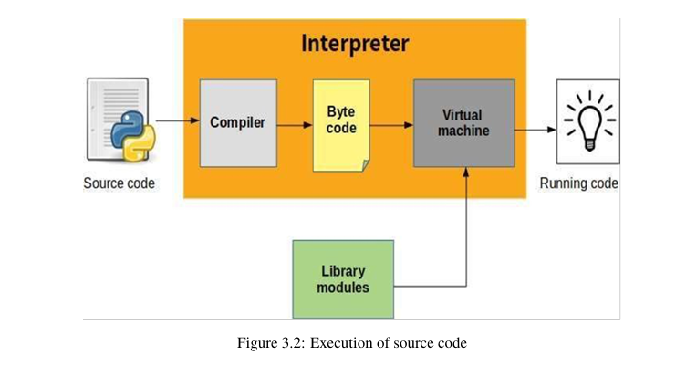

• Easy-to-read Python is more visible to the eyes and also better defined.

• Easy-to-maintain Python’s source code is fairly easy-to-maintain.

• Standard Library A very broad standard library Python’s bulk of the library is very portable and cross-platform compatible on UNIX, Windows, and Macintosh.

Mode Python has support for an interactive mode which allows interactive testing and debugging of snippets

of code. Features of Python

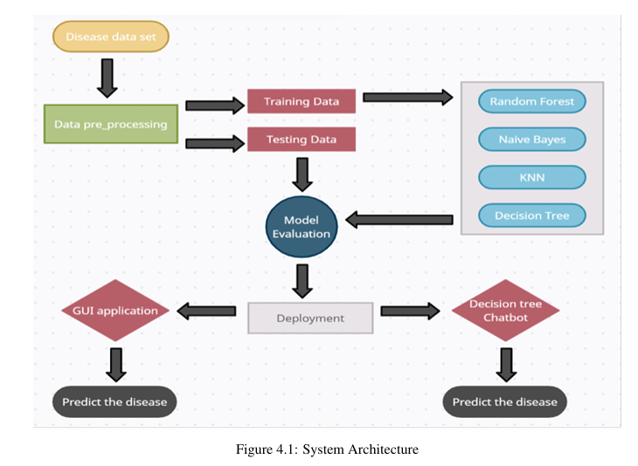

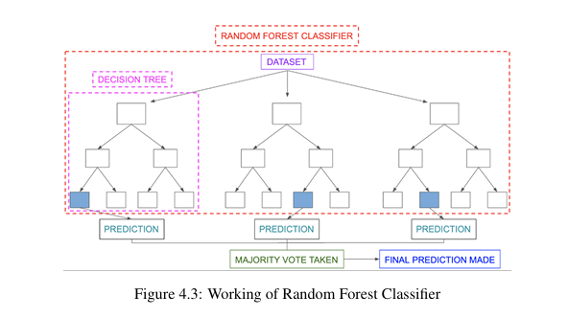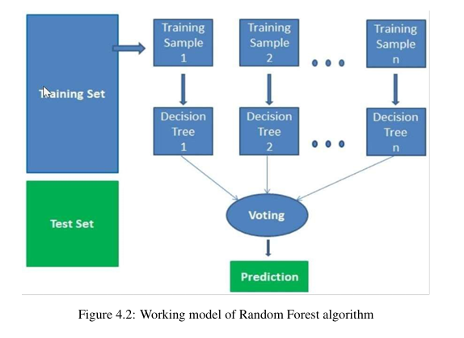

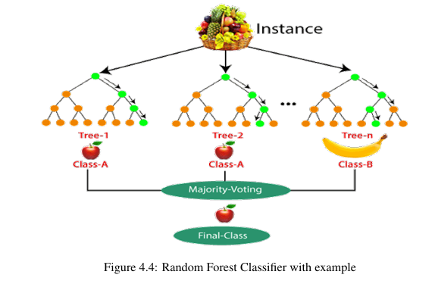

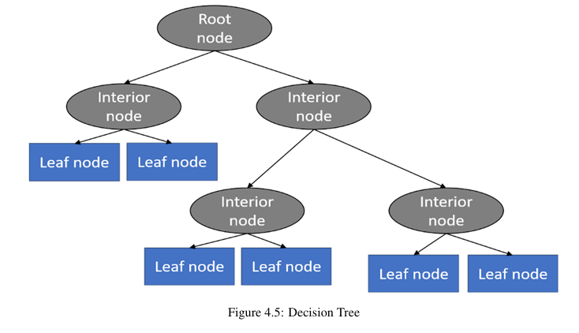

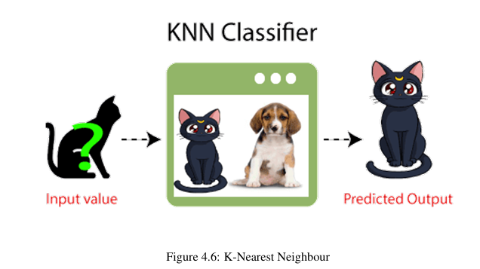

**V. CONCLUSION**

The Health Care System project demonstrates the potential of ML in disease prediction. It enables users to self-diagnose and seek timely medical attention. The system achieves high accuracy in disease prediction and serves as a digital healthcare assistant.

**VI. REFERENCES**

1. A. Durga Praveen et al. “Intelligent Liver Disease Prediction system using Machine Learning Models” ,vol 702. Springer, Singapore. 5 Jan, 2021.
2. Akash C. Jamgade, Prof. S. D. Zade,”Disease Prediction using Machine Learning”, International Research Journal of Engineering and Technology Volume: 06 Issue: 05 May 2019.
3. Ahan Chatterjee et al. “A Machine Learning Approach to prevent cancer”, DOI: 10.4018/978 1-7998-2742-9.ch007, 2021.
4. Goutam Chakraboty et al. “Predicting the Risk of Chronic Kidney Disease using Machine Learning Algorithm”, 11(1), 28 December, 2020 202.
5. G. Parthiban, S.K.Srivasta ”Applying Machine learning methods in Diagnosing Heart disease for Diabetic Patients” International Journal of Applied Information Systems (IJAIS)– ISSN: 2249-0868 Foundation of Computer Science FCS, New York, USA Volume 3– No.7, August 2012.
6. Sejin Park et al. “Machine-Learning-Based Elderly Stroke Monitoring System Using Electroencephalography Vital Signals”, 2021, 11(4), 1761.
7. Siddhika Arunachalam,” Cardiovascular Disease Prediction Model using Machine Learning Algorithms”, International Journal for Research in Applied Science, Engineering Technology ISSN: 2321-9653; IC Value: 45.98; SJ Impact Factor: Volume 8 Issue VI June 2020.
8. Upendra Kumar, “Applications of Machine Learning In Disease Pre-Screening”, 10.4018/978 1-7998-7705- 9.ch049, 2021.
9. Harshit Anand et al. “Hridaya Kalp: A Prototype for Second Generation Chronic Heart Disease Detection and Classification” ,31 July,2020.

[10] Isha Pandya et al, “Prediction of Heart Disease Using Machine Learning Algorithms”, 2018